

**DEPARTMENT OF COMPUTING**

**ISYS224 2019 S2 – ASSIGNMENT ONE (25%)**

**Due: 6pm Friday 13 September 201****9 (Week 7)**

**Database Design & Implementation**

Please Print Clearly In **CAPITALS**

|  |  |
| --- | --- |
| **Surname** |  |
| **First Name** |  |
| **Student ID** |  |
| **Signature** |  |

#### **Student Code of Conduct**

Macquarie University students have a responsibility to be familiar with the Student Code of Conduct: [https://students.mq.edu.au/study/getting-started/student-conduct​](https://students.mq.edu.au/study/getting-started/student-conduct)

### Student Support

Macquarie University provides a range of support services for students. For details, visit <http://students.mq.edu.au/support/>

**Task 1: Conceptual data model**

**--Add a screenshot of your conceptual data model in the form of an enhanced ER (EER) model (the model must be legible, when zoomed in). Note that you should not show the foreign keys in the EER model.**

**-- Identify and justify the use of, if any, generalization /specialisation, weak entity types, and attributes on relationships.**

**-- List your assumptions (if any) over and above what was provided in the problem domain description.**

**Task 2: Logical data model**

**--Add a screenshot of your logical data model (the model must be legible, when zoomed in).**

**-- Discuss how you translated the conceptual data model into the logical data model – briefly.**

**-- You may refer to specific translation / conversion rules discussed in the lectures (Week 3 slides, Chapter 17 of the textbook)**

**Task 3: Logical data model**

**-- List the functional dependencies (after making necessary assumptions) for each relation in the logical data model of Task 2.**

**-- Identify the normal form each relation is in and justify it according to the definition of the corresponding normal form (e.g., if a relation is already in 2NF and doesn’t have any transitive dependencies, it is in 3NF).**

**-- You may refer to the process of normalization discussed in the lectures (Week 4 slides, Chapters 14&15 of the textbook)**

**Task 4: DDL**

**-- Add your DDL scripts to implement the relevant tables in the relational data model in MySQL as per the requirements in the assignment description.**

**-- Add snapshots of the tables populated with data (the snapshots must be legible, when zoomed in)**

**Task 5: DML**

**--** **Add your DML scripts for the queries Q1 – Q5 as per the requirements in the assignment description.**

**-- Note that these SQL queries must be tested using the data you inserted in Task 4.**

**-- Add snapshots of the results / tables of the execution of the queries Q1 – Q5 (the snapshots must be legible, when zoomed in)**

**[DELETE THE FOLLOWING PRIOR TO SUBMISSION]**

**Submission**

You must submit all the work in two documents named **Assignment1.doc** and **Assignment1.sql** throughthe electronic submission site on [ilearn](https://ilearn.mq.edu.au/course/view.php?id=37242). If you modify your file(s) after submission, you may re-submit your assignment again before the due date.

**Notes**

* The **Assignment1.doc** file will be based on the template word file provided on [ilearn](https://ilearn.mq.edu.au/course/view.php?id=37242). Fill out the details provided on the first page of the template. For each task, follow the instructions given and add your answers in.
* You are not allowed to submit hand drawn images for the models/diagrams in Tasks 1 & 2; you should use a modelling or drawing tool as mentioned above. If you happen to submit hand-drawn images, you will NOT receive any marks for it.
* If your images for any task lack clarity and /or they are not legible, you will not be given any marks. Tutors can zoom in to check the diagrams. But we will not be able to increase the quality of the image. Whatever is submitted is the final submission. So, please make sure your images are legible.
* The **Assignment1.sql** file may be executed in the marking process and also manually marked for clarity. It is your responsibility to ensure the correctness of your DDL and DML scripts and they run perfectly under MySQL installed in the labs. The results of the execution of the scripts should also match those given in the **Assignment1.doc** file.
* SQL statements containing syntax errors are NOT acceptable. If you make syntax errors in your SQL statements, you may get zero marks.
* [PowerDesigner](https://www.sap.com/cmp/syb/crm-xm16-gam-it-dtcpdt/index.html) also offers a 30-day free trial period should you wish to install it on your personal computer to use it outside the opening hours of the labs in 9WW Level 1.

**Late Submission Policy**

No extensions on assignments will be granted without an approved application for [Special Consideration](http://from.mq.edu.au/MT0X0E0FUrrU200rm0JB0U0).

Late submissions will be accepted but there will be a deduction of 10% of the total available marks made from the total awarded mark for each 24 hour period or part thereof that the submission is late. For example, 25 hours late in submission for an assignment worth 10 marks – 20% penalty or 2 marks deducted from the total.

No submission will be accepted after solutions have been posted.

**Appendix**

**Sample CDM for Task 1 (in the book notation)**

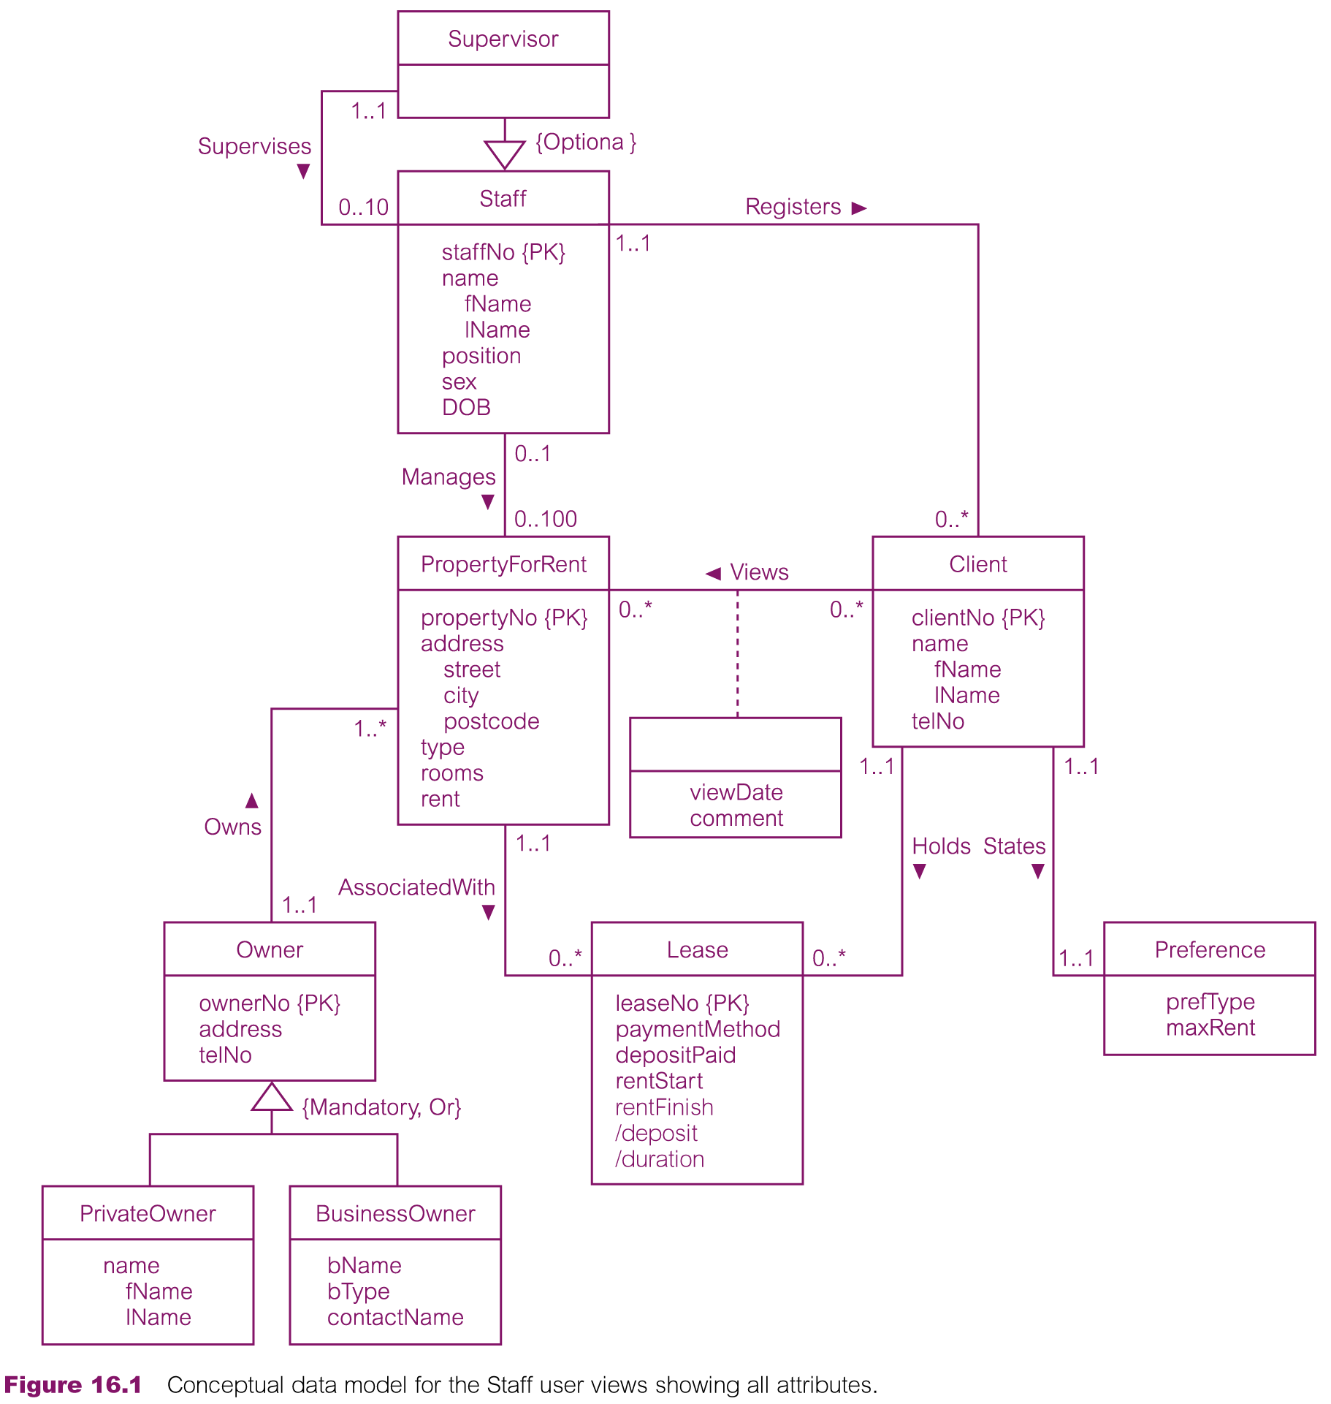

Page 529, Thomas Connolly and Carolyn Begg. [Database Systems. A Practical Approach to Design, Implementation, and Management](http://www.pearson.com.au/products/A-C-Connolly-Begg/Database-Systems-Global-Edtion-VitalSource-eText-A-Practical-Approach-to-Design-Implementation-and-Management/9781292061832?R=9781292061832), Sixth Edition, Pearson, 2014, ISBN-9781-2920-6183-2

**Sample relational schema for Task 2 (in the book notation)**

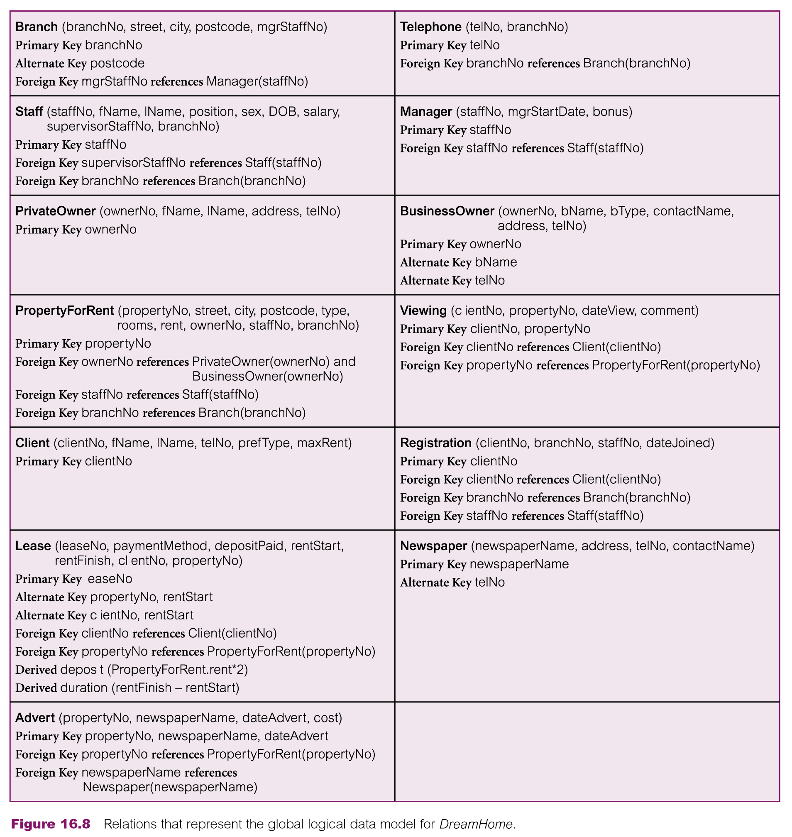

Page 553, Thomas Connolly and Carolyn Begg. [Database Systems. A Practical Approach to Design, Implementation, and Management](http://www.pearson.com.au/products/A-C-Connolly-Begg/Database-Systems-Global-Edtion-VitalSource-eText-A-Practical-Approach-to-Design-Implementation-and-Management/9781292061832?R=9781292061832), Sixth Edition, Pearson, 2014, ISBN-9781-2920-6183-2

**Sample relation diagram for Task 2 (in the book notation)**

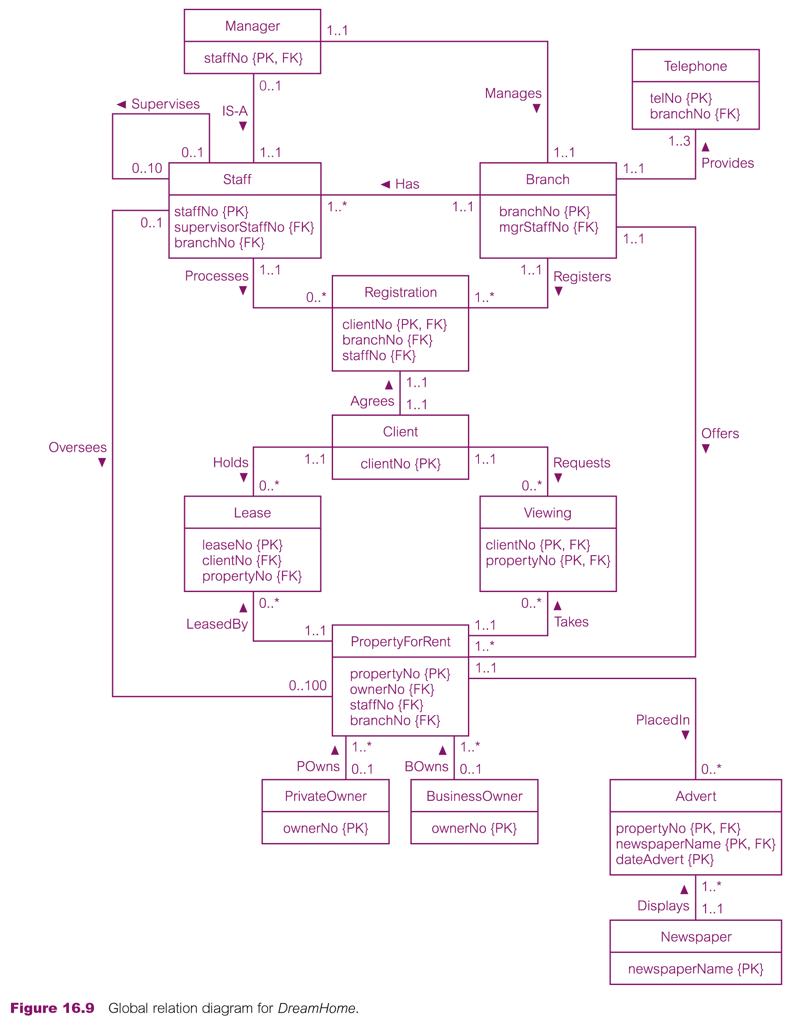

Page 555, Thomas Connolly and Carolyn Begg. [Database Systems. A Practical Approach to Design, Implementation, and Management](http://www.pearson.com.au/products/A-C-Connolly-Begg/Database-Systems-Global-Edtion-VitalSource-eText-A-Practical-Approach-to-Design-Implementation-and-Management/9781292061832?R=9781292061832), Sixth Edition, Pearson, 2014, ISBN-9781-2920-6183-2

**Sample (partial) answer for Task 3**

**Newspaper (newspaperName, address, telNo, contactName)**

**Assuming different newspapers can be located at the same address; contact names for different newspapers can coincide but newspaper names and tel numbers are unique. Also we assume one contact name per newspaper.**

**Nontrivial FDs:**

**newspaperName {PK} -> address, telNo, contactName**

**telNo {CK} -> newspaperName, address, contactName**

**There are no partial dependencies (2NF), no transitive dependencies (3NF), all determinants are candidate keys (BCNF).**

**There are no multi-valued dependencies either (4NF).**

**FYI**

**1NF – no repeating groups (only one value per each column & row intersection)**

**2NF – 1NF and every non-primary-key attribute is fully functionally dependent on any candidate key.**

**3NF -- 1NF and 2NF and no non-primary-key attribute is transitively dependent on any candidate key**

**BCNF – 3NF and every determinant is a candidate key**